The Major Issues Facing Staff in Islamic Banking Industry

Abstract
The research was mainly concerned about the challenges faced by the employees working in the Islamic banking Industry. A study was conducted on Islam based banks between the 5th and 22nd of March 2020 to identify the challenges faced by the employees. The results obtained aided in ascertaining the correlation between the employee challenges and its unique model of operation from conventional banks. The objectives of the research include generating results that assisted in developing employee skills. Also, investigating the nature and increase of the sales and bringing out ways of attracting customers to the banks were the last objectives of the study. The literature review confirmed the Islamic banking industry staff members had been struggling with the aspects mentioned earlier, and it was proven in the methodology part with the aid of descriptive statistics and observation. The sample used was composed of 200 participants, and recommendations were provided to address the identified employee challenges.

Keywords: Banks, Islamic Banking Industry, customer satisfaction, loan interest, staff, and skills.

1.0 Introduction
The Islamic banking industry (IBI) operates differently from other conventional banks, through offering interest-free products. Abdul-Majid et al. (2010) opined that there are various strategies applied in Islamic banks, and they have attracted not only praises but also critiques by the interested observers. The industry has received a considerable number of praise from customers and other parties due to its transition from a mere theory into a banking platform worthy of $2trillion. Importantly, IBI has attracted several non-Muslim customers because its system tends to be less risky yet stable as compared to the conventional banks. It is, however, worth noting that the industry is associated with various challenges, including late payments, unfavorable currency rates, and non-consideration of the poor and small traders (Hassan and Aliyu, 2018). The unique mode of operation has attracted critiques, which reveals that the Islamic banking industry has entirely ignored its underlying philosophy for the last few decades (Bose, 2018). It is, however, worth noting that the challenges have turned out to adversely impact the staff members who are mandated to oversee the operation of Islamic banks.

The Islamic banking staff has been struggling with putting in place effective strategies for creating awareness of its products, a situation that has reduced sales volume performance among the employees. Equally, the public does not have a clear view of what Islamic banking entails because the systems do not advocate for prioritizing its products and services (Hassan and Aliyu, 2018). The regulatory regime governing the Islamic banking industry does not allow the staff to harmonize their operations with those of the other banks; there impacting skill development adversely. Precisely, the team finds it challenging to shape their expertise concerning advancing technology due to the limited borrowing of techniques from conventional banks (Bose, 2018b). Notably, Islamic regulators advocates for developing the industry to a higher scaled baking sector as opposed to bringing in more customers and promoting the welfare of the staff. As a consequence, the employee tends to be limited since they cannot boots their sales volume by inviting more customers.

The research was vital in identifying the problems facing the staff working in the Islamic banking industry. The formulated recommendation aided in developing employee skills. Besides, the research contributed significantly to investigating nature and strategies for increasing sales. Additionally, it is through the research that staff got ways of attracting customers to the banks. The questions below aided the researcher in covering and understanding the Islamic banking mode of operation and the challenges facing its staff.
- Can Islamic banking staff members create awareness of bank products to the public?
- Does the banking system allow employee skill development through adopting techniques applied in conventional banks?
- Are the employee allowed to introduce the services offered to other potential customers?
- How does the Islamic bank thrive in the industry without charging its customers an interest?
- What are the benefits and disadvantages of excluding the poor and small traders from the Islamic banking industry?

2.0 Literature review
Integrating scientific developments in the banking industry has been a significant mark in the world's economy. The scientific improvement has induced banks to develop an interest in upgrading on management grounds due to the application of advanced technology (Jan, 2018). The customers tend to be much anxious because of ever-advancing developmental levels and the need for privacy. As a result, they seek financial assistance from institutions that have a well-grounded history in service delivery (Maghyereh, 2018). Additionally, customers tend to be selective when it comes to investing their stock and shares since the process requires an organization to have elevated money handling systems (Peppard, 2000). In connection, the Islamic banking industry is rated as among the stable sectors; however, it tends not to be effective in developing their staff's skills as well as their welfare.

The creative skills are mostly associated with financial institutions that have established a reliable market base in the banking industry. For the Islamic banking industry to attain acceptable levels of staff competency, there will be a need to implement total quality management and focus on elevating the current level of skills. Bose (2018b) suggests that the staff working in a banking environment are required to share their opinions freely when faced with a challenge in a bid to come up with informed decisions (Maghyereh, 2018). The previous research enlightens that IBI battle with maintaining employee key competencies, including management, technical, and humanitarian skills (Hassan and Aliyu, 2018). Notably, experience and personal qualities are the elements for the success that the banking sector should focus on when absorbing employees into the organization. The research will aid IBI in developing a spirit of creativity and initiative, thereby attaining the acceptable level of staff skills.

Islamic Banking institutions have sales staff and employees just like any other functional company, and they try all means necessary to hit the given target. The sales management team encourages their peers to work hard and achieve sales targets with the aid of administration, thereby accomplishing the assigned tasks effectively (Hassan and Aliyu, 2018). According to Jan (2018) suggests that the Islamic banking industry does rebuild the skills of the staffs’ skills in managing sales from various classes of persons since it focuses on persons with high-income earners. The Islamic banks are reported to have stagnant sales volume yet stable because they do not bring in more customers (Saeed, 1996). Overall, the systems are designed in such a way that they only meet the needs, desires, and preferences of high-income earners.

Islam banks are working towards coming up with new marketing strategies that will attract more non-Muslim customers .Word of mouth is the best marketing tool. The process of attracting and retaining customers is a complex undertaking since it entails providing the best products and services to other institutions. Azmat et al. (2015) reveals that Islamic banking systems have been finding it challenging to attract customers because of the competitive national interest rate, which is induced by the crowded industry. It is, however, worth noting that some customers have lost confidence in investing in the financial institution due to the continuous failures of several banks. The large and growing Islamic banks can elevate their market score by engaging in marketing campaigns to encourage non-Muslim customers to take loans and making more deposits (Okumus, 2005). Importantly, Traditional marketing strategies such as networking and communications should also be encouraged while minding conventional tactics.

After reviewing the research relating to Islamic banking, it was evident that researchers have not provided enough critiques on the same (Gerrard and Cunningham, 1997). Again, there is not enough research relating to how Islam banks can utilize management skills to attain better results (Hassan &Aliyu, 2018). Most of the information provided in the literature review wasmainly concerned about the importance of adopting staff skills, increasing sales, and providing the customers in the community with necessary information relating to banking. The information gathered while writing a literature review contributes significantly to understanding the modes of operation in the Islamic banking industry. Additionally, it is through the literature review that the reader can understand the nature of the Islamic banking industry in the United Arab Emirates (Bose, 2018a). Besides, the banks can get access to skills they can apply in their projects, and industry-related information to realize improved results.

3.0 Methodology
The primary purpose of the methodology was to provide the strategies that were used during data collection and analysis. The research methodology was defined as the discovery and systematic pursuit of knowledge. Kumar (2019) suggested that the research methodology provides a plan for digging deep into a study in an effort to generate concrete results. In this chapter, an approach was determined that aided the researcher during the study. The research focused on both quantitative and qualitative data collection. The quantitative part of data collection focused on questionnaires whereas qualitative concentrated on interviews. Questionnaires were designed to retrieve information about the critical problems experienced by Islamic bank staff members. The questionnaires were formulated in such a way to gather the necessary information from the distribution sample of employees from various Islamic banks. The design was achieved through conducting research, particularly by collecting technical data with the aid of the questionnaire and interviews.It is through the questionnaires that the researcher got a clear view of the problems facing the employees in the Islamic banking industry. Additionally, the questions provide a direction while designing data collection methods.

Staff members from various Islamic banks were interviewed to obtain views towards their challenges. During the interviews, the staff's opinion was recorded to arrive at an overall analysis. Two hundred staff members were interviewed, and the results obtained represent the entire staff in Islam banks. The participants were encouraged to provide honest answers to aid the study process and obtain a reliable outcome. The questionnaires used in the process were clear enough to the interviewers in addition to addressing the intended purpose of the research. As a result, the questions asked required short answers such as yes or no. The following set of opinions and questions overruled the interview process.
- Can Islamic banking staff create awareness of products to the public?
- Does the banking system allow employee skill development through adopting techniques applied in conventional banks?
- Are the employee allowed to introduce the services offered to other potential customers?

The questions of the research were to be analyzed with the help of an Islamic banking industry case study. The case study aimed to revealing the challenges faced by the staff who are mandated to oversee the operations of the Islamic banking industry. The case study analyzed obstacles faced by the team while trying to attract more customers in the bank. It is through the case study that the researcher got to know the sales and skill development challenges faced by the Islamic bank staff. The participants were issued with the questionnaires, as well as those interviewed were selected randomly from the active Islamic banks. The sample size for the study is was 200 staff from the departments of various banks. The study was conducted on eight banks in the UAE. Twenty-one of the participants came from Dubai Islamic Bank, Emirates Islamic had 19 interviewees , AlHilal 27,Sharja Islamic 26,Abu Dhabi Islamic 22, HSBCAmanah 23, Badr Al-Islami 19, and lastly 43 from Noor Islamic. The information obtained from the questionnaires was combined and analyzed to produce the outcome.

4.0 Analysis of data

4.1 Introduction
The survey was composed of four questions which aided in achieving the goal of research. Those who supplied with the questioners included 120 males and 80 males, totaling to 200 participants (Maghyereh, 2018). The questioners were modified and proof red for validity by DrShaima, who corrected 90% of the content. In this chapter, frequency percentages were presented using statistical tables. A statistical program was used for tabulation, open space classification, and the testing correlation between variables (see Figure 4.0).

Figure 4.0: males and 80 female of staffs for Dubai Islamic bank

4.1 Staff’s skills are essential in developing the institution

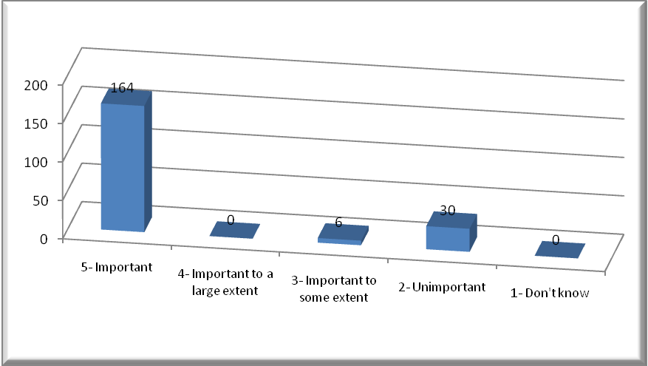
Figure 4.1: Staff Skills
Based on the above table, it evident that a large number of staff members from Islamic banks stress the need to develop staff skills in the bank (82%) (Abdul-Majid, Saal & Battisti, 2010). Developing skills is vital since only 15% of the total persons interviewed disagreed with opinion, and 3% could not give their views towards the use of technology to shaping the skilled competency of staff in a bank (see Figure 4.1).

4.2 Banks interest in bringing customers
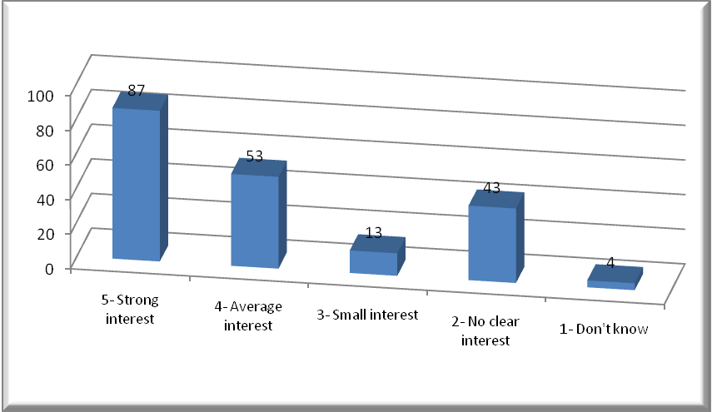
Figure 4.2: Bank interest in bringing customers
The above figure gives a clear view that 87 participants had a strong interest in bringing customers into the banks, 53 were on average status, 13 small, 43 not clear, and four did not know(Hassan &Aliyu, 2018). The above results bring forth an illustration that the banks do not involve employees in the process of making decisions and planning processes (see Figure 4.2).

4.3 bank interest in developing the skills of staff

Figure 4.3: bank takes an interest in developing the skills of employees
The above chart asserted that 48.5% of participants had a keen interest in developing the skills of staff in the bank, 32% were on average status, 7.5 % small, 11.5 % not clear, and 0.5 did not know (Hassan &Aliyu, 2018). The above results show that half of the employee did not understand the rationale behind core competency for the success of the bank (see Figure 4.3).

4.4 Customer service benefits to the banking industry

Figure 4.4: employees’ benefits for the bank from customer service
The above figure confirmed that 80% of 200 participants had a strong belief that the services offered to the customers are of much importance (Bose, 2018). 16.5% of the participants seemed to agree with the above statement partially, 1.5 did not know, 1% disagreed, and 1% strongly disagreed (Kadiwala & Prajapati, 2019). The results show that the Islamic banking Industry has tried to enlighten its employees on the benefits accrued from the developmental management of customer service.

4.5suggestions for an increase in sales

Figure 4.5: suggestions for an increase in sales
The above-presented figure confirmed that the employees in Islamic banking industry have a firm idea that sales volume needs to be increased. Approximately three-quarters of the total population, which is 140participantsstrongly, agreed that sales required to be boosted, 40 partially agreed, five did not know, 11 disagreed, and 4 had a strong feeling that there was no need for increasing sales (Kadiwala & Prajapati, 2019).

5.0 Discussion
The results generated in the section confirmed that most of the employees in the Islamic banks have a clear view that the development of skills is vital in an organization. It is worth noting that the Islamic banking industry has been educating its members on skill development, which would aid in achieving their goals and meeting the challenges facing the new banks (Maghyereh, 2018). The question relating to bringing customers into the banks did not attract much attention to almost half of the bank's staff. Precisely, only 78 out of 200 participants showed keen interest in encouraging customers to seek financial services from the banks (Tiwari et al., 2006). As a result, the banks needs to put more emphasis on the planning process while cooperating with various departments to bring customers in the banks, thereby increasing the number of service users.

The result in chapter four confirmed that 48% of employees had a strong feeling that their skills needed to be developed. Therefore, there seems to be no positive relationship between skill development and training as well as high academic performance. Based on the above illustration, it is evident that the banks have not been putting efforts to improve the performance of staff concerning the technological advancement. The Islamic banking industry staffs have a clear view that the services offered to the customers are vital in developing the activities of a banks. The results confirmed that over 80% of the employees had a strong feeling that the services offered to the customer are significant in taking the organization to the next level (Bose, 2018). The banks can boost their service provision through sales promotion, engaging with customers at a personal level, and offering other services that are not provided in other conventional banks. The question on employee suggestion was vital in proving the validity of the previous data that planning is pivotal in boosting the Islamic bank's staff skills as well as sales volume. Notably, 140 employees out of 200 suggested that they would actively support the strategies for increasing sales volume. The Islamic banking industry should get it clear that boosting sales volume is a complex undertaking since it entails effective management of finances, administrative activities, human resources, and general organizational aspects (Hassan and Aliyu, 2018).

6.0 Conclusions
All in all, the Islamic banking industry contributes hugely to community growth through funding customers' activities, thereby providing a balance between demand and supply of services offered. Banks contribute significantly to developing the economy through the mobilization of savings and providing a cost-effective environment for money exchange. However, the Islamic banking industry has been experiencing various challenges, including the need for sales increase, convincing customers, developing employee skills, and the development of competency among the employees. As a result, the research has provided recommendations for the above challenges and directives for further analysis. Need for Sales increase, bringing more customers, developing employee skills and the need for competency among the employees are crucial aspects discussed in the research. After reviewing the information provided by Islamic banking industry employees, it is evident that the banks are falling short of effective communication with the subordinate staff (Bose, 2018). The team lacks acceptable skills in the field of banking because they cannot accommodate the demands of the industry. The bank should review its policies on accommodation and rehabilitation of employees to ensure that core competencies are upheld while minding economic and humanitarian dimensions. The Islamic banking industry has been struggling with the issue of boosting its sales volume due to poor planning and making uninformed decisions. The staff does not have the necessary skills for marketing the products provided by the banks (Abdul-Majid, Saal & Battisti, 2010). The banks will need to put in place interventions for boosting its administrative functions, marketing, sales, and operational strategies. These interventions will pave the way for winning more customers and creating a substantial competitive edge.

7.0 Limitation and Future Research
The methodologies used limited research. The study encountered challenges from the interviewees. Some of the staff did not fill the questionnaires issued to them, thereby diminishing the reliability of research findings. Some of the techniques used, such as sampling, did not help in obtaining the opinions of staff attached to the remotely located branches. Also, most of the online interviews and questionnaires were not responded on time, which delayed the research findings. In the future, I would suggest the use of advanced tools that gather information from a larger population rather than focusing on samples. The existing research indicates that Islamic banking has been stable, yet it does not depend on low-income earners and small businesses. I would recommend for the examination of the strategies it has put in place to maintain stability. Notably, the banks have been facing challenges when it comes to raising the standards of services provided to be in line with the customer's demands. The underlying research enlightens that the staff in the Islamic banking industry do not have the capability of coping up with the ever-advancing level of technology (Kadiwala & Prajapati, 2019). The bank’s management should put more emphasis on employing only the potential candidates in addition to shaping their skills based on technological advancements. The research confirmed that the Islamic banking industry has been facing challenges in attracting customers to the banks. The primary cause of this issue is poor marketing strategies, which cannot induce a potential customer to have confidence in the services provided (Hassan & Aliyu, 2018). The banks can boost their service provision through sales promotion, engaging with customers at a personal level, and offering other services not provided in other conventional banks.

References
Abdul-Majid, M., Saal, D. S., & Battisti, G. (2010). Efficiency in Islamic and conventional banking: an international comparison. Journal of productivity analysis, 34(1), 25-43.
Azmat, S., Azad, A., Ghaffar, H., & Bhatti, I. (2015). Why interest free Islamic banking is not free from interest? Typescript) https://www. deakin. edu. au/__data/assets/pdf_file/0003/392295/islamic-banking-notfree-from-interest-Azmat-Azad-Ghaffar-and-Bhatti. pdf (accessed on Oct. 22, 2017).
Bose, I. (2018a). Employee empowerment and employee performance: An empirical study on selected banks in UAE. Journal of Applied Management and Investments, 7(2), 71-78.
Bose, I. (2018b). The Strategic Environment of the Aviation Industry in UAE: A Case Study on Etihad Airways. IIUM Journal of Case Studies in Management, 9(1), 21-27.
Gerrard, P., & Cunningham, J. B. (1997). Islamic banking: a study in Singapore. The International Journal of Bank Marketing, 15(6), 204-216.
Hassan, M. K., & Aliyu, S. (2018). A contemporary survey of Islamic banking literature. Journal of Financial Stability, 34, 12-43.
Jan, M. T. (2018). Will It Survive? Challenges Faced by Islamic Banking and Finance in Today’s World. Journal of Islamic Finance, 176(6217), 1-10.
Maghyereh, A. I. (2018). Bank Competition, Concentration and Risk-taking in the UAE Banking Industry. Economia Internazionale/International Economics, 71(2), 129-148.
Okumus, H. (2005). Interest-free banking in Turkey: a study of customer satisfaction and bank selection criteria. Journal of Economic Cooperation, 26(4), 51-86.
Peppard, J. (2000). Customer relationship management (CRM) in financial services. European Management Journal, 18(3), 312-327.
Saeed, A. (1996). Islamic banking and interest: A study of the prohibition of riba and its contemporary interpretation (Vol. 2): Brill.
Tiwari, R., Buse, S., & Herstatt, C. (2006). Mobile banking as business strategy: Impact of mobile technologies on customer behaviour and its implications for banks. Paper presented at the 2006 Technology Management for the Global Future-PICMET 2006 Conference.

